Fake News Detection Using Random Forest Algorithm

with Intel-Optimized Python Libraries

Team: Phoenix

MRCET

July 14, 2023

### 1. Introduction

#### 1.1 Problem Statement

Detecting fake news is a complex task due to the constant evolution of techniques used by perpetrators. Traditional approaches often need help to keep up with the ever-changing nature of fake news.

#### 1.2 Background

In the era of rapid information sharing, fake news poses a significant threat to the integrity and reliability of news articles. Fake news encompasses fabricated or misleading information presented as factual news. It can manifest in various forms, including clickbait, satire, propaganda, or malicious content.

#### 1.4 Approaches to Fake News Detection

Detecting fake news is crucial to safeguard individuals from misinformation, preserve the credibility of news sources, and enable informed decision-making in various domains. Approaches to fake news detection include linguistic analysis, fact-checking, source credibility assessment, and machine learning-based methods. Machine learning algorithms offer scalable and efficient solutions.

#### 1.5 Report Structure

This report provides an overview of fake news detection and its significance. It then delves into the Random Forest algorithm, discussing its advantages and implementation details. The integration of Intel-optimized Python libraries with sci-kit-learn (sklearn) is explained, emphasizing the performance benefits. The report concludes with an evaluation of the implemented system, an analysis of the results, and a discussion of the implications of fake news detection.

### 2. Random Forest Algorithm

#### 2.1 Overview of Random Forest

Random Forest is an ensemble learning algorithm that combines multiple decision trees to make predictions. It leverages the concept of bagging and voting to improve accuracy and robustness. Each decision tree in the forest is trained on a randomly selected subset of the training data and features.

#### 2.2 Algorithm Workflow

The Random Forest algorithm involves the following steps:

a. **Dataset Splitting:** The dataset is divided into a training set and a testing set. The training set is used to build the Random Forest model, while the testing set is used to evaluate its performance.

b. **Feature Selection and Engineering:** Relevant features are selected or engineered to capture the characteristics of fake news articles. For example, text preprocessing techniques like tokenization, stemming, and removing stop words can be used to extract meaningful information from textual content. This step is crucial for achieving accurate predictions.

c. **Training Multiple Decision Trees:** Several decision trees are trained using different subsets of the training data and features. Each tree is constructed using a random selection of samples with replacement (bootstrap aggregating or bagging).

d. **Aggregating Predictions:** During the prediction phase, each decision tree in the forest provides a vote on the classification of a given article. The final prediction is determined by majority voting or weighted voting.

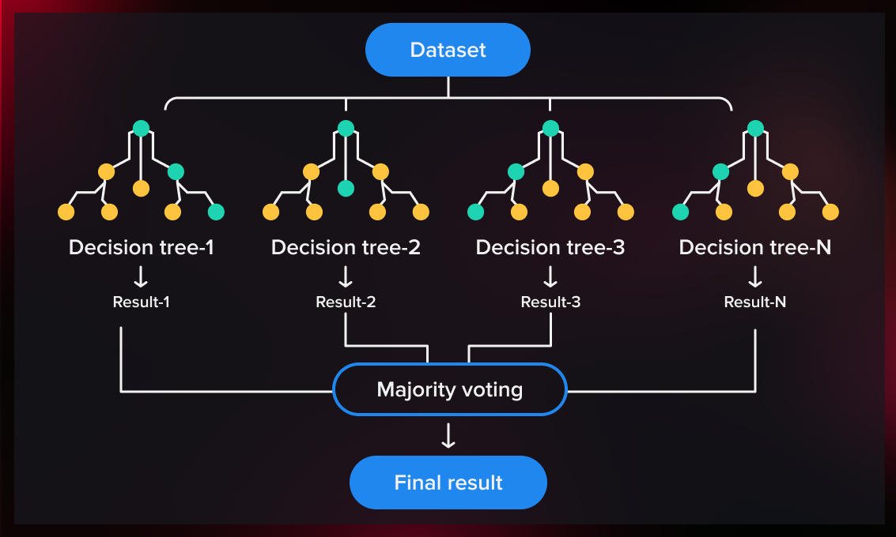

#### 2.3 Training and Prediction Process

During the training process, each decision tree in the Random Forest algorithm is trained using a different subset of the training data and features. The decision trees are constructed using techniques like recursive partitioning (e.g., the Gini index or entropy) to determine the splits that best separate the data.

During prediction, each decision tree provides a vote on the classification of a given article. The final prediction is determined by aggregating the votes through majority or weighted voting. The use of multiple decision trees and the voting mechanism improve the overall prediction accuracy and robustness.

### 3. Implementation with Intel-Optimized Python Libraries

#### 3.1 Introduction to Intel-Optimized Python Libraries

Intel-optimized Python libraries, such as scikit-learn (sklearn) and NumPy, provide enhanced performance and optimization capabilities for machine learning tasks. These libraries leverage Intel's advanced technologies, such as vectorization, multi-threading, and parallel computing, to improve the execution speed and efficiency of algorithms.

#### 3.2 Performance Benefits and Optimizations

Intel-optimized libraries provide several performance benefits and optimizations for fake news detection:

a. **Vectorization:** Intel-optimized libraries take advantage of SIMD (Single Instruction, Multiple Data) vectorization instructions supported by modern CPUs. This allows for performing operations on multiple data elements simultaneously, leading to faster computation of features and improved efficiency.

c. **Parallel Computing:** Intel-optimized libraries employ parallel computing frameworks, such as Intel Threading Building Blocks (TBB), to distribute computational tasks across multiple cores. This parallelization enhances the scalability and efficiency of the Random Forest algorithm. Intel-optimized libraries utilize multi-threading techniques to parallelize computations across multiple CPU cores. This enables concurrent execution of tasks, reducing the overall processing time and enhancing performance.

### 4. Evaluation and Results

#### 4.1 Performance Evaluation

The performance of the implemented system is evaluated using the selected evaluation metrics. Comparative analysis is conducted with baseline approaches to assess the effectiveness and superiority of the Random Forest algorithm with Intel-optimized libraries.

#### 4.2 Analysis of Results

The analysis of the evaluation results provides insights into the strengths and limitations of the implemented system. It identifies the most influential features for fake news detection and examines the impact of using Intel-optimized Python libraries on the performance and efficiency of the Random Forest algorithm. The accuracy of the trained model is 99.1 %.



#### 5.SampleOutput:

#### 

### 6. Conclusion:

The report presented an investigation into fake news detection using the Random Forest algorithm implemented with Intel-optimized Python libraries. The Random Forest algorithm demonstrated high accuracy, robustness, and the ability to identify influential features for fake news detection.

The integration of Intel-optimized libraries with sci-kit-learn (sklearn) further enhanced the performance and efficiency of the algorithm, leading to faster execution times and improved resource utilization.